PROJECT DOCUMENTATION

IDEATION PHASE

DEFINE THE PROBLEM STATEMENT

|  |  |
| --- | --- |
| COURSE | DIGITAL MARKETING |
| ZONE | 18 |
| TEAM ID | NM2023TMID08848 |
| PROJECT NAME | CREATE BRAND NAME,LOGO AND EMAIL USING CANVA |

Problem Statement:

Create a problem statement to understand your customer's point of view. The Customer Problem Statement template helps you focus on what matters to create experiences people will love.

A well-articulated customer problem statement allows you and your team to find the ideal solution for the challenges your customers face. Throughout the process, you’ll also be able to empathize with your customers, which helps you better understand how they perceive your product or service.

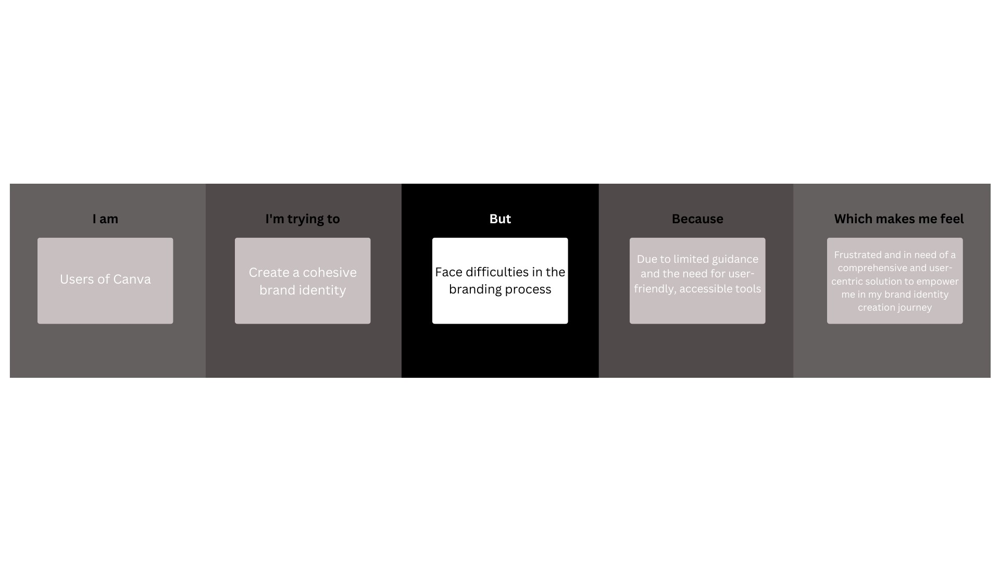

IDEATION PHASE

Empathize & Discover

An empathy map is a simple, easy-to-digest visual that captures knowledge about a user’s behaviours and attitudes.

It is a useful tool to helps teams better understand their users.

Creating an effective solution requires understanding the true problem and the person who is experiencing it. The exercise of creating the map helps participants consider things from the user’s perspective along with his or her goals and challenges.

**EXAMPLE: PERFUME BRAND CREATION**

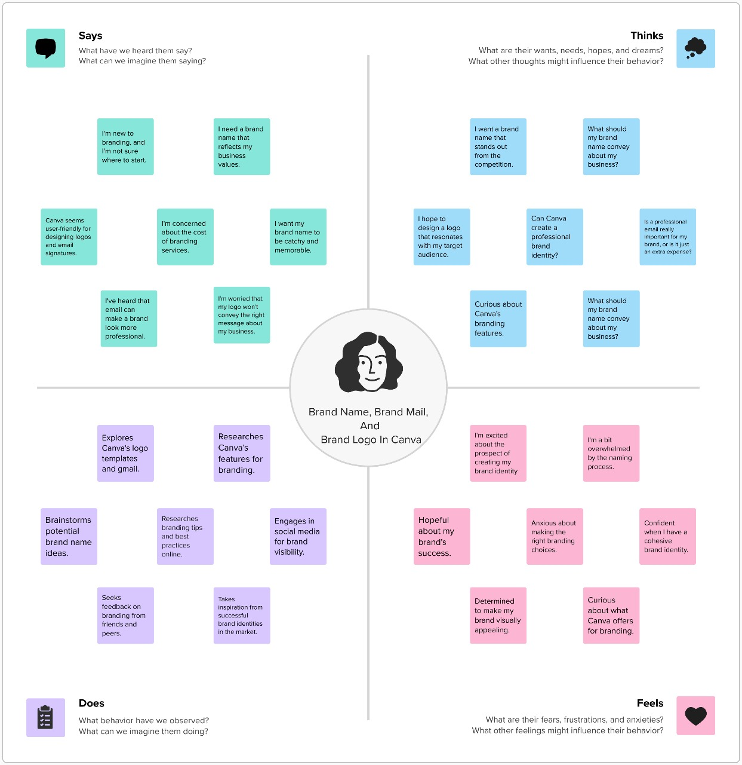

IDEATION PHASE

Brainstorm & Idea Prioritization Template

**Brainstorm & Idea Prioritization Template:**

Brainstorming provides a free and open environment that encourages everyone within a team to participate in the creative thinking process that leads to problem solving. Prioritizing volume over value, out-of-the-box ideas are welcome and built upon, and all participants are encouraged to collaborate, helping each other develop a rich amount of creative solutions.

**Step-1: Team Gathering, Collaboration and Select the Problem Statement**

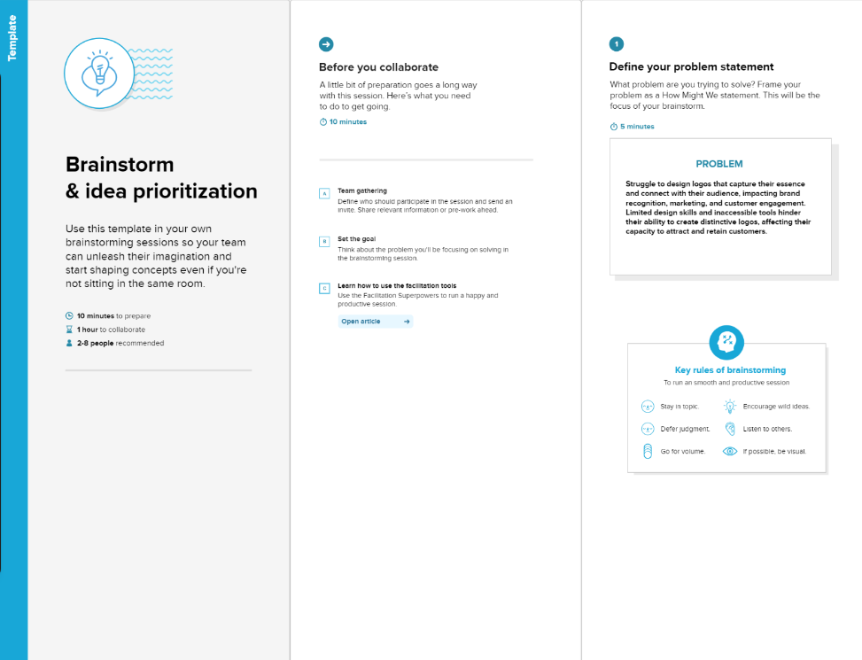

**Step-2: Brainstorm, Idea Listing and Grouping**

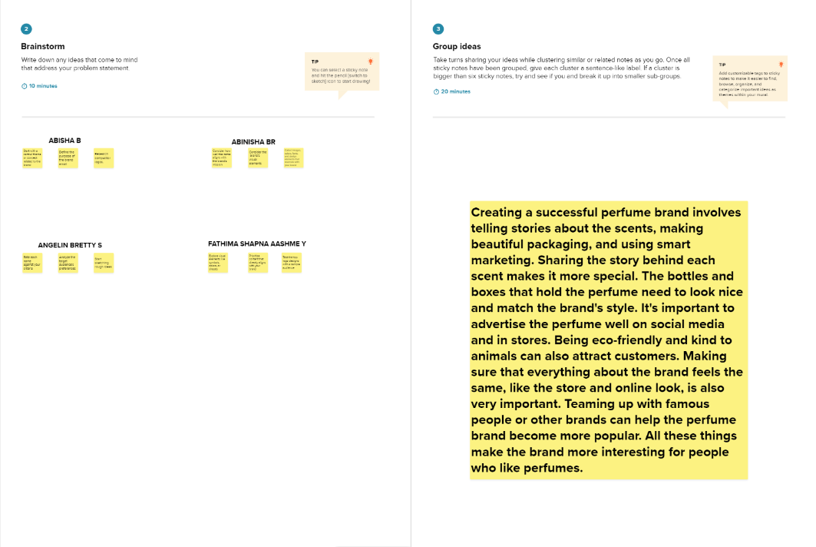

**Step-3: Idea Prioritization**

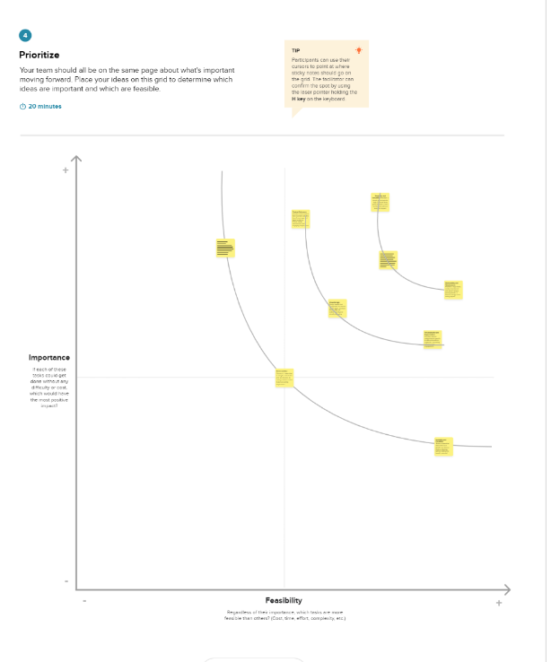

SOLUTION ARCHITECTURE

**Creating a brand name, brand mail, and brand logo is an essential part of establishing your brand identity**

* **Decide on the style and elements you want in your logo (e.g., colors, fonts, symbols, etc.).**
* **Consider hiring a professional graphic designer to create a custom logo.**
* **If you choose to design the logo yourself, you can use a tool like Canva or Adobe Illustrator.**
* **Ensure the logo is versatile, works well in various sizes and applications (online, print, merchandise, etc.).**
* **Protect your logo by trademarking it if necessary.**

**Solution Architecture Diagram:**

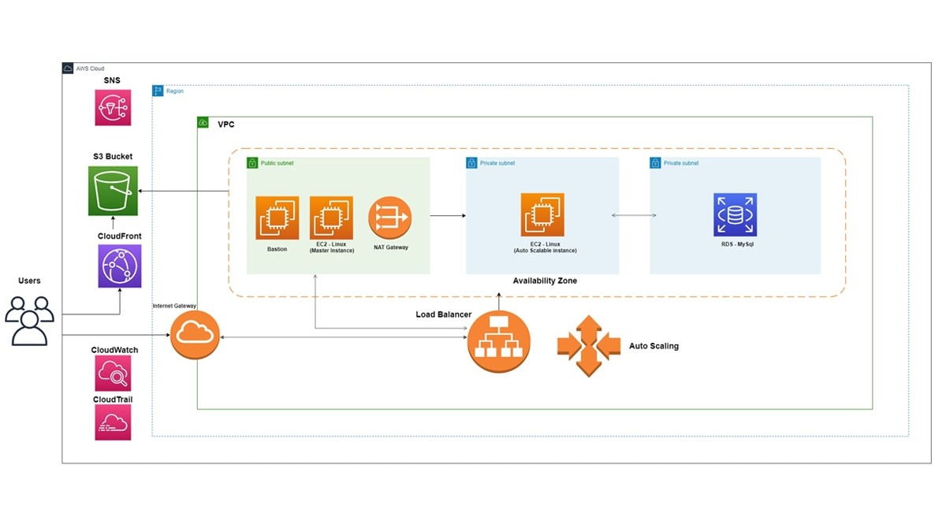**Reference:** [**https://www.nopcommerce.com/images/case-studies/perfume-world/1.5.jpg**](https://www.nopcommerce.com/images/case-studies/perfume-world/1.5.jpg)

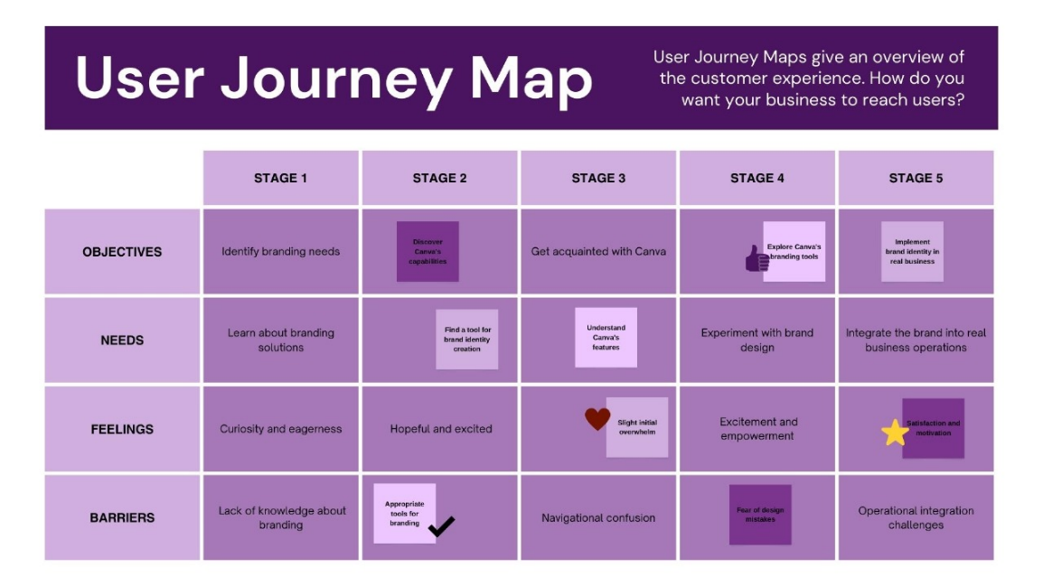

CUSTOMER JOURNEY MAP

REQUIREMENT ANALYSIS

**FUNCTIONAL REQUIREMENTS:**

|  |  |  |
| --- | --- | --- |
| **NO** | **FUNCTIONAL REQUIREMENTS** | **SUB REQUIREMENTS** |
| **1** | **Text and Design tools** | Text manipulation and graphic design tools to create and experiment with various font styles, shapes, and color schemes for brand name and logo design. |
| **2** | **Customization Capabilities** | Customizable templates and elements for logo creation, allowing users to personalize and align the logo with the brand's identity. |
| **3** | **Email Template Library** | A diverse library of email templates designed for various purposes (newsletters, promotions, etc.), allowing for customization to match the brand's style. |
| **4** | **Mobile Responsiveness** | Ensuring the email content and logo designs are responsive and adaptable to different screen sizes and devices. |
| **5** | **Collaborative Features** | Collaboration tools enabling multiple users to work together on brand creation projects, facilitating teamwork, feedback, and real-time editing. |

**NON-FUNCTIONAL REQUIREMENTS:**

|  |  |  |
| --- | --- | --- |
| **NO** | **NON-FUNCTIONAL REQUIREMENTS** | **DESCRIPTION** |
| 1 | **Performance** | * **Speed**: Ensure a quick response time for loading and rendering designs in the platform, promoting an efficient workflow. * **Scalability**: The platform should support the creation of various brand elements without performance degradation as the user base grows. |
| **2** | **Usability** | * **User Interface:** Provide an intuitive and user-friendly interface to cater to users with varying levels of design expertise. * **Accessibility:** Ensure the platform is accessible across different devices and browsers, offering a consistent experience. |
| **3** | **Security** | * **Data Protection:** Implement secure data storage and transmission protocols to safeguard user-created content and personal information. * **User Privacy:** Maintain stringent measures to protect user privacy and data confidentiality during the creation process. |
| **4** | **Reliability** | * **Stability:** Ensure stability and reliability of the platform, minimizing downtime and glitches during the design process. * **Consistency:** Provide consistent and accurate design rendering across different browsers and devices. |
| **5** | **Compatibility** | * **Software Integration:** Support integration with other design tools or software, allowing users to import/export elements to and from other platforms. * **File Format Support:** Ensure compatibility with multiple file formats for exporting designs, making it adaptable to various applications. |

FLOW CHARTS

A Data Flow Diagram (DFD) is a traditional visual representation of the information flows within a system. A neat and clear DFD can depict the right amount of the system requirement graphically. It shows how data enters and leaves the system, what changes the information, and where data is stored.

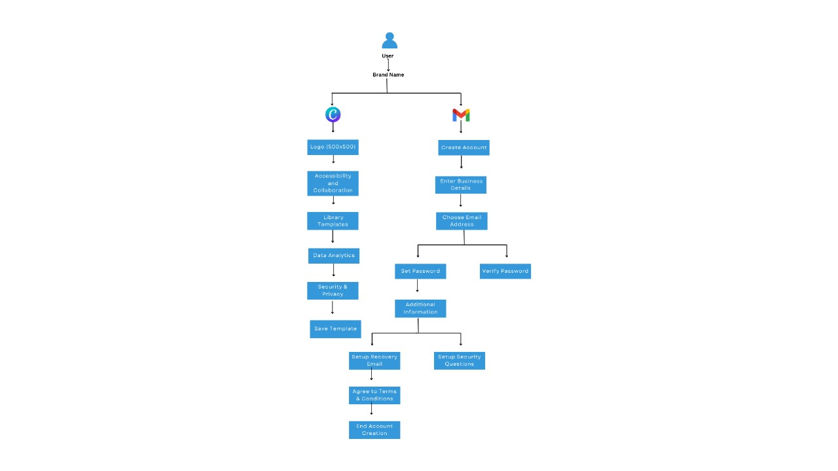

**Technical Architecture**

**The technical architecture for creating a brand name, brand email, and brand logo in Canva is a complex blend of front-end and back-end technologies, cloud infrastructure, design tools, security, and user management. It's designed to provide a user-friendly and reliable platform for individuals and businesses to create and manage their brand elements.**

**Technical Architecture Diagram:**

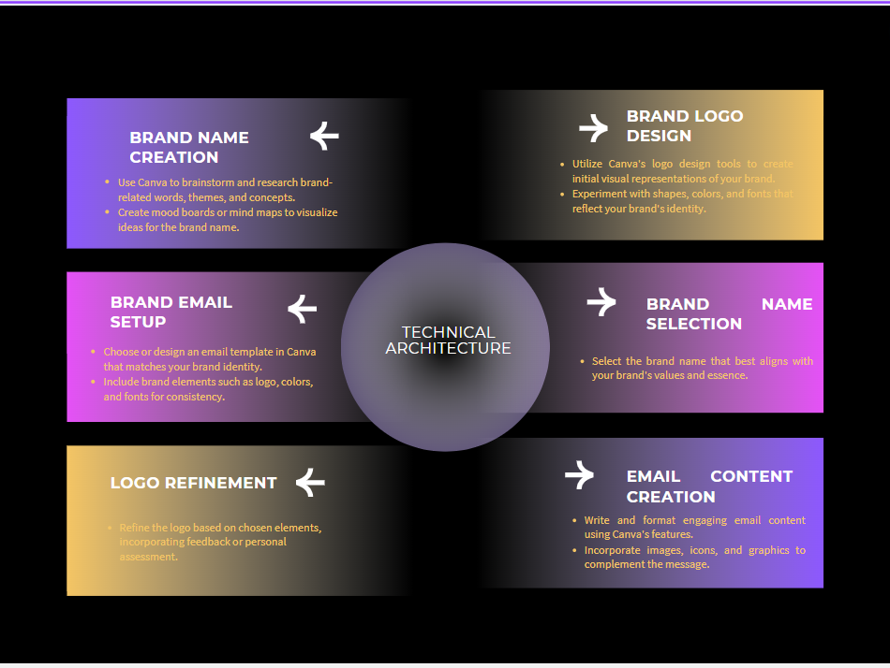

OPEN SOURCE FRAMEWORK

For brand name, logo, and email creation, the usage of specific open-source frameworks might be limited, as these activities primarily involve design and visual representation. However, certain open-source tools and platforms can facilitate the creation process:

**Open-Source Graphic Design Tools:**

1. **Inkscape:**
   * A powerful open-source vector graphics editor suitable for logo design and creating scalable designs.
2. **GIMP (GNU Image Manipulation Program):**
   * A versatile open-source raster graphics editor used for image editing, suitable for refining and manipulating design elements.

**Collaborative Design Platforms:**

1. **Gravit Designer:**
   * An open-source design platform that allows for collaborative work on various design projects, including logos and brand elements.

**Email Design and Marketing:**

1. **Mautic:**
   * An open-source marketing automation platform that can be used for managing email campaigns and designing email content.

**Font and Typography:**

1. **Google Fonts:**
   * Though not a framework, it's an open-source platform offering a wide range of fonts that can be used in brand name design.

Open-source frameworks and tools are commonly used in design and branding, offering flexibility, cost-effectiveness, and a collaborative community. Here are some open-source options for brand name, logo, and email creation:

### Brand Name Creation:

1. **Wordmark.it:** A web-based open-source tool that allows you to preview your chosen brand name in different fonts, helping you select the one that best suits your brand identity.
2. **NameMesh:** An open-source domain name generator that assists in finding available domain names related to your brand name.

### Logo Design:

1. **Inkscape:** A powerful open-source vector graphics editor that enables you to create and customize logos with a wide range of tools and features.
2. **GIMP (GNU Image Manipulation Program):** A popular open-source raster graphics editor that can be used for logo design and image editing.

### Email Design:

1. **Mailtrain:** An open-source email marketing platform that allows you to design and send email campaigns, manage subscribers, and track performance.
2. **Mosaico:** An open-source email template builder that provides a user-friendly interface for designing responsive email templates.

These open-source tools provide valuable resources for brand creation, allowing you to design and manage brand elements effectively while benefiting from the support and contributions of the open-source community.

THIRD-PARTY API’S

In the creation of brand elements such as a brand name, logo, and email design, the involvement of third-party APIs may not be the primary method. However, in some instances, these APIs can provide supplementary support or tools:

**Use Cases of Third-Party APIs:**

* **Design Resources:**
  + Integration with image repositories or design libraries that offer graphics, icons, or templates which can be incorporated into logo or email design platforms.
* **Font or Color Libraries:**
  + APIs offering extensive font or color libraries that can be utilized in creating brand name typography or logo color schemes.
* **Email Marketing Tools:**
  + Integration with third-party email marketing platforms that provide analytics, automation, or templates to enhance email design and distribution.
* **Trademark and Domain Name Search:**
  + APIs providing trademark or domain name search functionality for checking the availability of brand names.
* **Collaboration and Version Control:**
  + Tools supporting version control or collaborative design features that can be integrated within the design process.
* **Stock Image Libraries:**
* Designers often use third-party stock image APIs to access a wide range of high-quality images for use in logo and email design. These images can add visual appeal and uniqueness to brand elements.
* **Typography Services:**
* Third-party APIs that provide access to a variety of fonts and typography styles can be integrated into design tools to enhance the creative possibilities for brand name and logo design.
* **Email Marketing Services:**
  + In the context of email creation, third-party email marketing platforms like Mailchimp or SendGrid may be used to send and manage email campaigns, ensuring efficient delivery and tracking of email performance.
* **Social Media Integration:**
  + Brand creation often extends to social media branding. Third-party APIs can be used to integrate social media sharing and posting features directly into the email design or for promoting the brand name and logo on social platforms.

While the direct usage of third-party APIs may not be a standard practice in brand creation, the integration of relevant third-party tools and services can streamline the design process and enhance the overall brand identity, especially in areas like image resources, typography, email marketing, and social media presence.

CLOUD DEPLOYMENT

Cloud deployment in brand creation primarily involves utilizing cloud-based services to facilitate the storage, sharing, and collaborative development of brand assets. Although these tools are not specific to brand name, logo, and email creation, they can significantly aid in the overall brand creation process:

**Cloud Deployment Services:**

1. **Cloud Storage Platforms:**
   * Services like Google Drive, Dropbox, or OneDrive facilitate the storage of brand-related documents, design drafts, logo iterations, and email templates, enabling easy access and collaboration among team members.
2. **Collaborative Platforms:**
   * Tools such as Google Workspace, Microsoft Office 365, or collaborative design platforms like Figma or Canva for Teams, allow real-time collaboration on brand assets, fostering teamwork in brand creation.
3. **Version Control and Document Sharing:**
   * Services like GitHub for version control or collaborative Google Docs for brand documentation offer efficient tracking of changes and shared access to brand guidelines and documentation.

**Benefits of Cloud Deployment:**

* **Accessibility:** Cloud deployment allows team members to access and work on brand elements from anywhere, enhancing remote collaboration.
* **Version Control and Backup:** It provides versioning features that keep track of changes made to brand assets, and data backup features reduce the risk of data loss.
* **Scalability:** Cloud-based services offer scalable storage and resource availability, accommodating the growing needs of brand creation projects.

Utilizing cloud deployment in brand creation enhances collaboration, accessibility, and scalability, streamlining the development and management of brand assets across various brand elements.

### Brand Name Creation:

1. **Collaborative Cloud Tools:** Use cloud-based document collaboration tools like Google Docs or Microsoft 365 to brainstorm, create, and share brand name ideas with team members in real time.
2. **Online Research and Domain Availability:** Access online domain name registrars and trademark databases from the cloud to verify domain and trademark availability for the chosen brand name.

### Logo Design:

1. **Cloud-Based Graphic Design Tools:** Utilize cloud-based graphic design tools like Canva, Figma, or Adobe Creative Cloud for collaborative logo design and access design assets from anywhere with an internet connection.
2. **Version Control:** Cloud-based version control systems like GitHub or Bitbucket can be used to track changes in logo design files and collaborate with team members.

### Email Design:

1. **Cloud-Based Email Marketing Platforms:** Leverage cloud-based email marketing platforms such as Mailchimp or SendGrid to design, send, and manage email campaigns efficiently, with the ability to access analytics and insights from any location.
2. **File Storage and Collaboration:** Store and collaborate on email design assets and templates in cloud storage solutions like Google Drive or Dropbox, facilitating easy access for team members working remotely.

Cloud deployment offers the advantage of accessibility, real-time collaboration, and the ability to work from anywhere with an internet connection. This can be particularly beneficial for design teams and marketers involved in brand name, logo, and email creation, as it streamlines the workflow and enhances collaboration.

PROJECT DEPLOYMENT PHASE

NO OF FUNCTIONAL FEATURES INCLUDED IN THE SOLUTION

Functional features for brand name, logo, and email creation involve specific capabilities that enable users to develop and customize these elements effectively. Here are key functional features for each:

**Brand Name Creation:**

1. **Text Manipulation:**
   * Tools allowing users to input, format, and experiment with various text styles, fonts, and arrangements to create and visualize potential brand names.
2. **Visual Inspiration:**
   * Mood board creation or image integration features aiding in brainstorming and visualizing ideas for brand name creation.
3. **Font Libraries:**
   * Access to a diverse range of fonts and typography options to find the perfect style that aligns with the brand's identity.

**Logo Design:**

1. **Graphic Design Tools:**
   * Tools for creating and manipulating shapes, colors, and design elements to conceptualize and refine the brand logo.
2. **Template Library:**
   * Ready-made logo templates or design starting points to inspire and assist users in creating logos across different styles and industries.
3. **Customization Options:**
   * Ability to customize logo elements such as shapes, colors, and layout to craft a unique and brand-aligned design.

**Email Content Creation:**

1. **Email Template Variety:**
   * A selection of templates for different types of email campaigns (e.g., newsletters, promotions), allowing customization to match the brand's style.
2. **Content Editing Tools:**
   * Text, image, and design tools to create and edit engaging email content, enabling users to craft visually appealing and informative emails.
3. **Responsive Design Features:**
   * Features ensuring that the email design is responsive and displays well on various devices, allowing seamless interaction across different platforms.

These functional features in brand name, logo, and email creation assist users in developing cohesive and visually appealing brand elements aligned with their brand's identity and objectives.

CODE LAYOUT READABILITY AND REUSABILITY

In the context of brand name, logo, and email creation, code layout, readability, and reusability may not directly apply, as these elements are typically created using design tools rather than programming or code development. However, I can provide guidance on best practices for readability and reusability in the broader context of design creation:

**Readability:**

1. **Consistent Naming Conventions:**
   * Use clear and consistent names for elements within your design project. For instance, use a clear naming convention for different versions of your logo or sections within an email template.
2. **Clear Organization:**
   * Group and organize design elements logically within your design software, making it easier to navigate and locate specific components.
3. **Commenting or Documentation:**
   * While not code-related, consider using annotations or descriptions within your design project to explain the purpose or usage of specific elements, making it clearer for collaborators or future use.

**Reusability:**

1. **Template Creation:**
   * Develop reusable templates for email designs or logo variations within your design software. This allows you to reuse base designs for similar campaigns or iterations.
2. **Component Libraries:**
   * Create libraries of reusable elements or components that are commonly used in your designs. This includes commonly used fonts, color palettes, or logo elements that can be easily integrated into different projects.
3. **Version Control or Iteration Management:**
   * Keep versions of your designs or iterations for easy reference or reuse. This enables you to revisit previous versions or reuse elements that worked well in earlier designs.

While traditional coding principles don't directly apply to graphic or design software, employing these practices can enhance the readability and reusability of design elements, leading to more efficient and consistent brand creation processes.

UTILIZATION OF ALGORITHMS , DYNAMIC PROGRAMMING, OPTIMAL MEMORY UTILIZATION

In the context of brand name, logo, and email creation, the utilization of algorithms, dynamic programming, or optimal memory utilization is not a direct application as these activities typically involve design, creativity, and visual representation rather than algorithmic processes or memory management.

However, certain principles and practices can indirectly contribute to efficient brand creation:

**Optimal Design Process:**

1. **Efficient Iterative Design:**
   * Utilize an iterative design process, refining brand elements gradually to achieve the desired outcome efficiently.
2. **Reusable Elements:**
   * Create reusable design elements like color schemes, fonts, or specific brand motifs to maintain consistency across different branding materials.

**Organizational Efficiency:**

1. **Structured Design Workflow:**
   * Develop a structured and organized workflow for brand creation, facilitating easier collaboration and design iteration.
2. **Version Control:**
   * Maintain different versions of design files to track changes, enabling easy retrieval or comparisons between iterations.

**Memory Optimization (Digital Resources):**

1. **File Compression:**
   * Utilize file compression techniques for storing design assets or templates, optimizing storage space.
2. **Efficient File Formats:**
   * Use file formats that balance quality and file size, allowing for optimal storage and performance.

While these practices don't directly involve algorithms, dynamic programming, or memory management in the traditional sense, they do contribute to an efficient, organized, and structured approach to brand creation within the realm of design and visual representation.

DEBUGGING AND TRACEABILITY

In the context of brand name, logo, and email creation, "debugging" and "traceability" are not commonly used terms. However, concepts similar to these practices can be applied for quality assurance and maintaining a clear record of design iterations.

**Debugging (Quality Assurance):**

1. **Quality Review and Iterative Refinement:**
   * Conduct thorough reviews of brand elements (logo, brand name, email design) to identify any inconsistencies, errors, or design flaws. Iterate on the designs to refine and improve their quality.
2. **Collaborative Feedback:**
   * Solicit feedback from team members or stakeholders to identify and rectify design issues, ensuring that the final output aligns with the brand's vision.

**Traceability (Record Keeping):**

1. **Version Control:**
   * Maintain a clear record of different versions or iterations of brand elements to trace changes made during the design process. This helps in tracking and reverting to specific stages of the design.
2. **Documentation of Design Process:**
   * Maintain documentation or design notes outlining the evolution of brand elements. This can include explanations of design choices, modifications, and the rationale behind certain design decisions.

While not identical to traditional software debugging or traceability, applying similar principles in the design process can help maintain quality and a clear track of design changes, ensuring the brand elements are consistently refined and aligned with the brand's identity and objectives.

EXCEPTION HANDLING

In the context of creating brand elements such as a brand name, logo, and email design, "exception handling" is not a typical practice as it is within software development. However, similar principles can be applied to manage unexpected situations or challenges that might arise during the creation process:

**Adaptability to Design Changes:**

1. **Iterative Approach:**
   * Embrace an iterative approach to design, allowing for modifications or changes as the brand elements evolve.
2. **Feedback Incorporation:**
   * Adapt to feedback or unexpected design requirements that might arise during the collaborative creation process.

**Quality Assurance:**

1. **Error Identification and Correction:**
   * Regularly review and identify errors or inconsistencies within the brand elements and correct them promptly.
2. **Adapting to Evolving Requirements:**
   * Be prepared to adjust the design process to meet changing brand requirements or unforeseen challenges.

**Collaboration and Problem Resolution:**

1. **Collaborative Solutions:**
   * Engage with team members or stakeholders to resolve design discrepancies or unexpected challenges.
2. **Creative Problem-Solving:**
   * Apply creative problem-solving approaches to address unexpected hurdles in the design process.

While not directly mirroring software exception handling, incorporating these adaptive and responsive approaches can effectively address unexpected challenges or changes that might emerge during the brand creation process for brand name, logo, and email design.

PERFORMANCE AND FINAL SUBMISSION PHASE

MODEL PERFORMANCE METRICS

In the context of brand creation (brand name, logo, and email design), the concept of "model performance metrics" is typically associated with evaluating the effectiveness of machine learning or statistical models. However, in the domain of design, specific quantifiable performance metrics may not directly apply.

Instead, the evaluation of success in brand creation involves more qualitative and subjective measures. Here are some indicative considerations:

**Brand Name:**

1. **Distinctiveness and Uniqueness:**
   * Measure how unique the brand name is within its industry or market segment, ensuring it stands out.
2. **Relevance to Brand Identity:**
   * Assess how well the brand name aligns with the brand's vision, values, and target audience.

**Logo Design:**

1. **Recognition and Memorability:**
   * Gauge how easily the logo is recognized and remembered, a critical aspect of effective branding.
2. **Scalability and Adaptability:**
   * Assess how well the logo retains its impact when scaled to different sizes or used in various contexts.

**Email Design:**

1. **Engagement and Conversion Rates:**
   * Measure the effectiveness of email designs based on open rates, click-through rates, and conversion rates.
2. **Mobile Responsiveness:**
   * Evaluate how well the email design adapts to different devices and screen sizes.

While these aspects lack standardized numerical metrics, they serve as indicators of success in brand creation. Success in brand development is often measured subjectively, based on brand recognition, audience engagement, and alignment with the brand's values and objectives.

Top of Form